Ansys Government Initiatives (AGI)
Systems Tool Kit (STK) Evaluation License Application Form for iCASE 2022

During the iCASE 2022 CubeSat Mission Design Contest, Analytical Graphics Inc. encouraged participants to increase their creativity in Satellite Mission Planning. AGI is provided free of charge System Toolkit (STK) software for participating teams during the Satellite Mission Planning contest period to use.

Systems Tool Kit (STK) for Satellite Design and Operations: STK is built for any mission in any phase of the life cycle. From concept through operations, STK can help with system architecture, trajectory design, orbit determination, subsystem analysis and much more. STK has been used by thousands of engineers and operators on hundreds of successful satellite programs. Fly your satellites with the same software used to design and test them.

Small Satellite Training Series Videos from AGI:
1. Orbit Design Course
https://p.widencdn.net/dw0ajv/Small-Satellite-Series-1-of-3---Orbit-Design?download=true
2. Solar & Power Design Course
https://p.widencdn.net/rkftyi/Small-Satellite-Series-2-of-3---Solar--Power-Design?download=true
3. Communication Design Course
https://p.widencdn.net/wpxnnz/Small-Satellite-Series-3-of-3---Communications-Design?download=true

Contacts:
Mr. Sam
TEL: 0921 935 313
EMAIL：sam@persistek.com

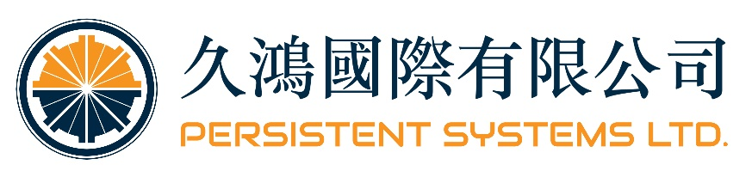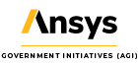
- The STK license is only for iCASE 2022 CubeSat Mission Design Contest use.
- The Logo are welcome to shows in the participant teams’ presentation.
- AGI has the right to issue or to not issue the license to foreign participant teams.
STK Software Application Form for International Conference on Astronautics and Space Exploration 2022 (iCASE 2022)

CUBESAT MISSION DESIGN CONTEST

- Description of the Satellite Mission:
- Team Members:
First Name: | Last Name: | AGI Account  (Email) : | Computer Host ID: | Citizenship: | Phone Number:
 |  |  |  | Taiwan
 |  |  |  | Taiwan
 |  |  |  | Taiwan
 |  |  |  | Taiwan
Organization Name :
Organization Address:
Website:

